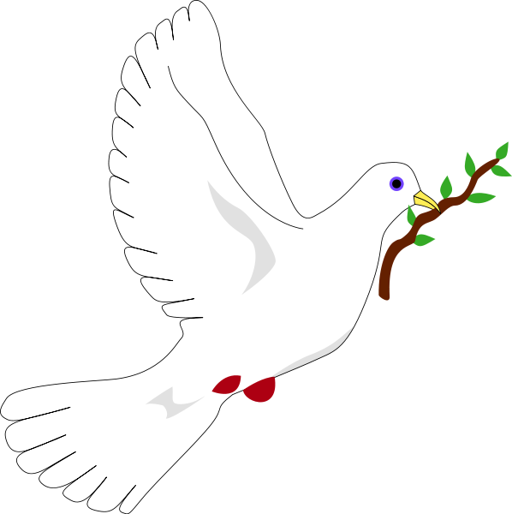
November - Peace
‘Blessed are the peacemakers for they shall be called the children of God.’ Matthew 5:1
December - Love
‘Love thy neighbour as thyself’. Matthew 22:39
September- Respect
‘Love one another warmly as Christian brothers and sisters, and be eager to show respect for one another.’ Romans 12:10
October –Responsibility
‘ I will choose good over bad and I will accept responsibility for my decisions’ Joshua 24:15
January – Cooperation
‘Let us be concerned for one another to show love and do good.’ Hebrews 10:24
February - Honesty
‘An honest person is as brave as a lion’. Proverbs 28:1
March - Faith
‘Now faith is confidence in what we hope for and assurance about what we do not see.’ Hebrews 11:1
April – Humility
‘Humble yourselves before the Lord and he will lift you up.’ James 4:10

June - Trust
‘When I am afraid, I put trust in you.’ Psalm 56:3

May - Hope
‘For I know the plans I have for you,” says the Lord. “They are plans for good for not for disaster, to give you future and hope.” Jeremiah 29:11
July-Care
‘Be kind to one another, tender hearted, forgiving one another, as God in Christ forgave you.” Ephesians 4:32

